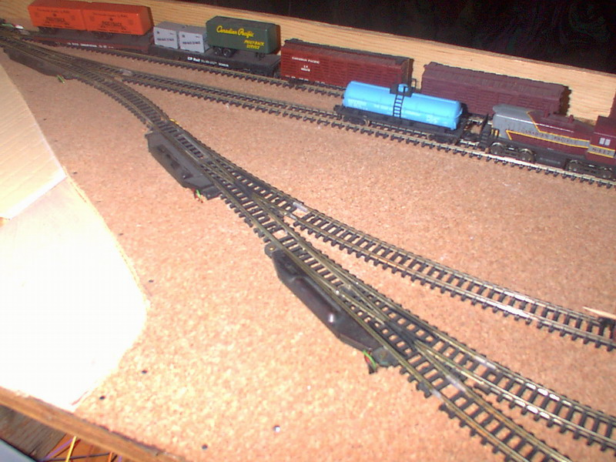

Here is the switches I needed to replace with the #4’s with @2 #6’s because my Atlas GP 7’s front guard was catching on the electric switch motors causing the engine to bind and stop.I needed a smoother run for my track plan to allow free rolling of equipment

